CUBe – Workshops day 1 to day 3 (summary)



Document ID | SOP-DEP-ENV-001
Product | DEP
Environment | ENV
Confidentiality Level | Internal / Restricted

CONTENTS
1 DOCUMENT INFORMATION 3
1.1 Validation 3
1.2 Document Distribution 3
1.3 Version Control 3
2 PURPOSE & CONTEXT 4
2.1 About this document 4
2.2 Scope 4
2.3 Roles & Responsibilities 4
2.4 Terminology 4
2.5 Conventions Used 4
3 WORKSHOP DAY 1 6
3.1 General Notes 6
3.1.1 Roles & Responsibilities 6
3.2 Pricing Function 6
3.2.1 Vendor Pricing App 6
4 SECTION / PROCEDURE 2 8
4.1 Subtitle 8
4.1.1 Subsection 8
5 APPROVAL SIGNATURES 9

DOCUMENT INFORMATION

Validation
Name |  | Role | Date (dd/mm/aa)
Issued by | Oscar Rondon | Technical Writer | 26/02/2026
Verified by
Approved by | Anthony Bures | Digital Development Manager | 26/02/2026

Document Distribution
Normal | Role

Version Control
Version | Date | Author | Description of changes
1.0 | 26/02/2026 | Oscar Rondon | Summary of the workshops for Phase 2

PURPOSE & CONTEXT

About this document
The purpose of this document is to present a summary of the CUBE Phase 2 workshops, so any developer can come back to review.

Scope
Scope of the standard operating procedure (SOP)
In scope:
- Anything mentioned in the workshops
Out of scope:
- Anything that was out of the workshops

Roles & Responsibilities
Role | Responsibilities
Technical Writer | Create the document and share it with the digital development team

Terminology
Term Used | Description
SPS | Service Providers Specialist.
PSP | Premier Service Provider (Hands-on approach, strong relationship, above average service). Only build in certain areas.
Hauler | Any service provider.

Conventions Used
The following structures are used as recommendations.
Tip: A recommendation or useful advice

Warning: A warning or important notice

Note: A notice.

WORKSHOP DAY 1
Our main focus on a day-to-day basis is to of course ensure that the company has providers set in place in all areas of the US for our four main product lines, which are toilets, dumpsters, storage containers and fencing.

General Notes
Our biggest focus in doing that is to ensure that none of the provider service areas are overlapping. We want to make sure that they are in their own individual space.

Roles & Responsibilities
- Pilar: Service Provider Specialist (81 accounts / 81 providers)
- CD, Andrew, Alisha: Service Provider Representatives (service providers documents, tickets, orders are fulfilled, etc)
- Sandra: Lead Service Provider

Pricing Function

Vendor Pricing App
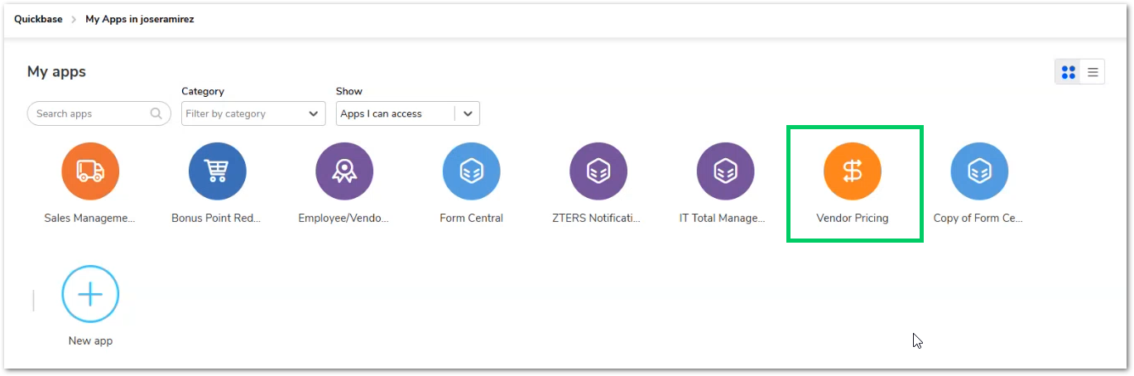
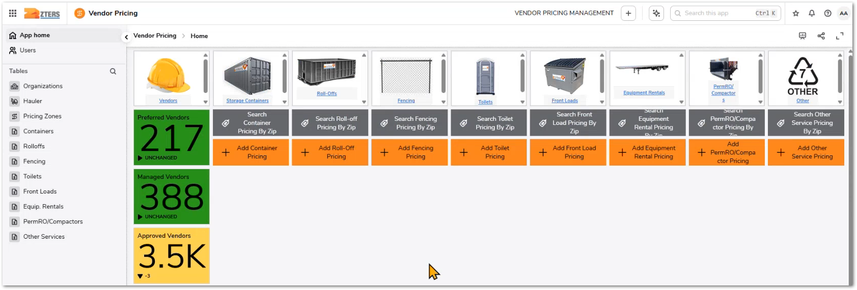

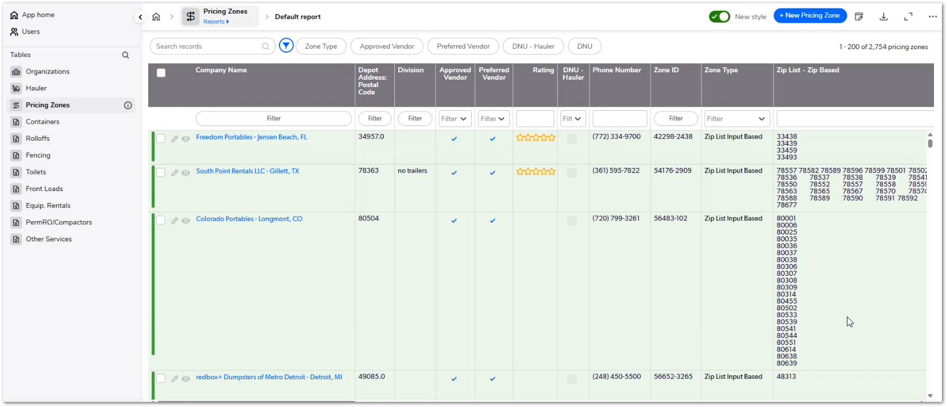

User Story: New Pricing Zone
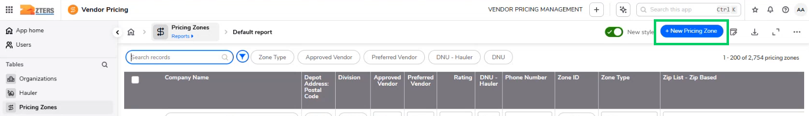
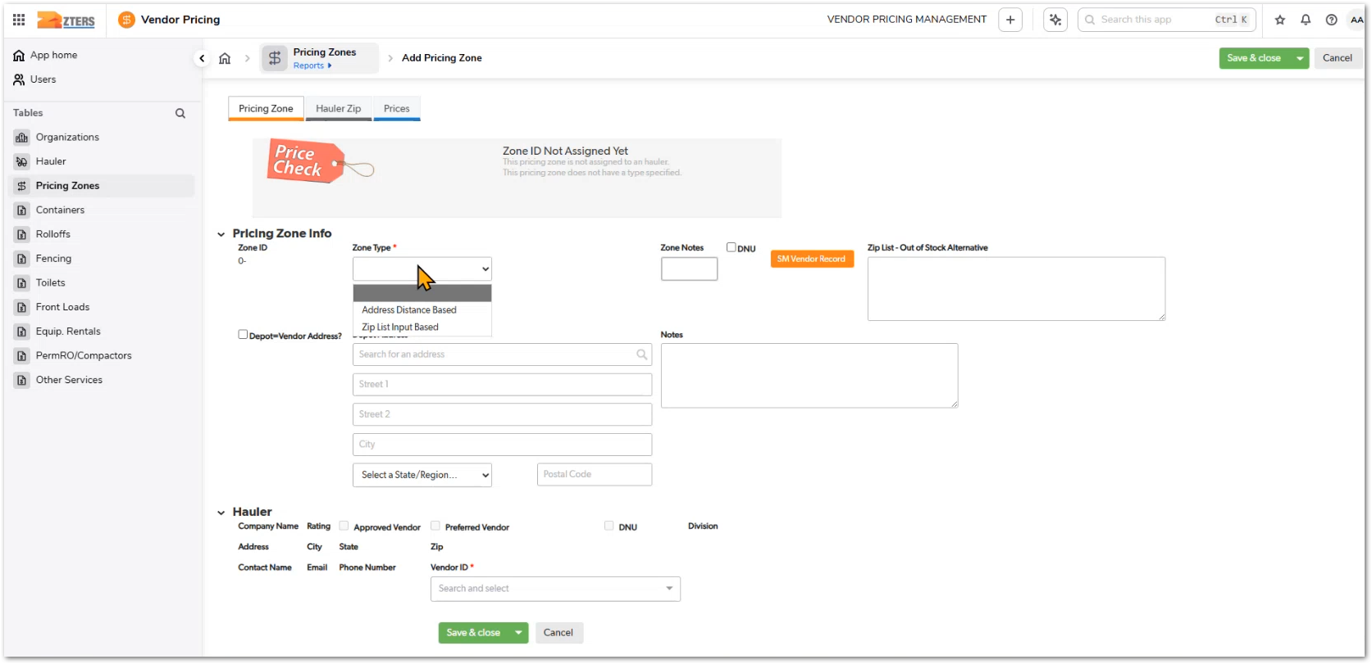
Zone Type:
- Zip list input based
- Address distance based

User Story: Delete Pricing Records
Soft deleting is needed across all the application (permission restriction).

SECTION / PROCEDURE 2
Add the content here…

Subtitle
- Step 1
- Step 2
- Step 3

Subsection
- Step 1
- Step 2
- Step 3

APPROVAL SIGNATURES
Digital signature blocks below are formatted for DocuSign / Adobe Sign.
Role | Name | Digital Signature Block | Date (dd/mm/aa)
Approval’s role | Approval’s name |  | 29/12/2025

--- END OF THE DOCUMENT ---

